

DRINK-O-MATIC

**Test Plan**

*Purpose: Documentation of testing all procedures with in the Drink-O-Matic application.*

**Revision History**

|  |  |  |  |
| --- | --- | --- | --- |
| Date | Version | Author | Description |
| 01/15/2016 | 1 | PS | Reset Datasets within Visual Studio. |
| 02/2/2016 | 2 | PS | Redesigned forms to garner faster results |
| 02/16/2016 | 3 | PS | Tested UI with seniors. |
| 02/29/2016 | 3.5 | PS | Finalized Code |

Table of Contents

1. Overview 4

1.1. Purpose 4

1.2. Scope 4

2. Testing Summary 4

2.1. Scope of Testing 4

3. Analysis of Scope and Test Focus Areas 4

3.1. Release Content 4

3.2. Regression Testing 4

3.3. Platform Testing 4

4. Progression Test Objectives 4

5. Progression Test Objectives 4

6. Other Testing 4

6.1. Security 4

6.2. Stress & Volume Testing (S&V) 4

6.3. Connectivity Testing (CT) 4

6.4. Disaster Recovery/Back Up 4

6.5. Unit Testing 4

6.6. Integration Testing 4

7. Test Strategy 4

7.1. Test level responsibility 4

7.2. Test Type & Approach 4

7.3. Build strategy 4

7.4. Test Execution Schedule 4

7.5. Facility, data, and resource provision plan 4

7.6. Testing Tools 4

7.7. Testing Handover Procedure 4

7.8. Testing Metrics 4

8. Test Environment Plan 4

8.1. Test Environment Man 4

8.2. Test Environment Details 4

8.3. Establishing Environment 4

8.4. Environment Control 4

8.5. Environment Roles and Responsibilities 4

9. Assumptions and Dependencies 4

9.1. Assumptions 4

9.2. Dependencies 4

10. Entry and Exit Criteria 4

11. Administrative Plan 4

11.1. Approvals 4

11.2. Test Milestones and Schedule 4

11.3. Training 4

11.4. Defect Management 4

12. Definitions 4

13. References 4

14. Points of Contact 4

# Overview

## Purpose

The purpose of this document is to define:

* The test scope parameters
* To define bugs and issues before release
* Detail text experiences with in application while use

## Scope

*Detail the scope of this document. For example:*

This document details the testing that will be performed and administered by me, Patt Sperl, at key points throughout the development of this project.

* UI with various age groups
* Testing will be performed on various input devices
* Resources needed and used: touch screen, mouse, computer and or stylus

# Testing Summary

## Scope of Testing

### In scope

During testing users tested application on the development computer itself as well as a beta version that was loaded to a cloud storage site in which they installed the application on various devices ranging from: tablets, laptops, desktops and even an old POS machine. Each machine was running Windows 7 or newer at time of testing.

### Out of scope

While speaking about application to possible clients they tried on development computer. No direct integrations was performed at this time.

# Analysis of Scope and Test Focus Areas

## Release Content

Do to beta status any release would be done on an install USB flash drive. Future versions will be released on a USB, CD-ROM, DVD-ROM or direct download from the manufactures website. Each version released will have a simple to use user manual, contact information for customer service as well as a hard copy of the drinks in the database for a small extra charge.

## Regression Testing

*No regression is needed at this time.*

## Platform Testing

* Not testing on old versions of Windows as of now.
* Testing on Windows 7
* Testing on Windows 8
* Testing on Windows 10

# Progression Test Objectives

* Combobox Dataset Display Test: Displayed information from table correctly
* DataGridView DataSet Display Test: Displayed selected columns correctly
* Layout Alignment: Each section aligns with previous one
* Buttons: They and work

# Other Testing

## Security

*Test multiple user names and passwords to login. All functional.*

## Stress & Volume Testing (S&V)

*Since this is based on a local database and it is a single user application there was no evidence to any stress on the application itself.*

## Connectivity Testing (CT)

*Later iterations of this application will require network capabilities to auto update with a service with the users require it. At this time the connection to the local database is functional and working.*

## Disaster Recovery/Back Up

*In final release backing up to external device will be recommended and implanted with in the application itself. With beta releases easy to follow directions on manual backup will be included.*

## Integration Testing

*TBD. At this time there is not integration testing do to the nature of the application.*

# Test Strategy

## Build strategy

*The build will be as one install. This is keeping in the mindset of the K.I.S.S. thinking. One file to open. Click ok. Done.*

## Test Execution Schedule

*(See attached)*

## Facility, data, and resource provision plan

### Test environment

* *Any computer of end user willing to try*
* *Home, office, or business*

### Testing Requirements

*;* Each person involved in testing will need the following access:

* A web browser with access to the intranet
* Access to the Drinks database, and relevant database SQL tool
* Access to Drink-o-Matic EXE
* Access to Microsoft Excel to raise defects

### Resources & Skills

* A resource with SQL skills;
* A resource with .NET skills to resolve any defects;
* A resource with internet technologies understanding.

## Testing Tools

The following tools will be used for testing:

| Process | Tool |
| --- | --- |
| Test case creation | Microsoft Word |
| Test case tracking | Microsoft Excel |
| Test case execution | Manual |
| Test case management | Microsoft Excel |
| Defect management | Microsoft Excel |

## 

## Testing Metrics

The following metrics will be gathered and stored and used in future development:

* Age of user
* Sex of user
* Type of user
* Location of user
* Type of computer
* What was attempted
* Was the attempt successful
* Reason for successful

# Test Environment Plan

## Test Environment Plan Diagram

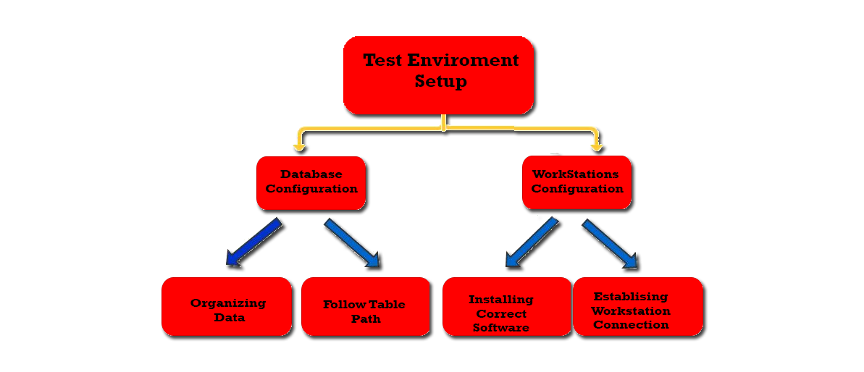

## Test Environment Details

### Testers

*Define the number of testers who will be involved in testing and their:*

* 3 Testers
  + One with no real computer knowledge
  + One with no real bartending skills
  + One who claims to know everything
* Hardware requirements
  + Laptop
  + Tablet
  + Desktop
  + Point of sale

### Hardware and Firmware

**RAM**

* 32 bit OS: 1 GB
* 64 bit OS: 2 GB

**Screen**

* Resolution: 1024 x 768 or higher

**HDD**

* 120gb or larger

**USB**

* 2.0 or higher

### Software

**OS**

* Windows 7 Professional and Ultimate (32 bit)
* Windows 7 Professional and Ultimate (64 bit)
* Windows 8.1 and 8.1 Pro (32 bit)
* Windows 8.1 and 8.1 Pro (64 bit)
* Windows 10 Professional and Ultimate (32 bit)
* Windows 10 Professional and Ultimate (64 bit)

**Applications**

* Word or Notepad
* Excel
* SQL Server
* Web Browser

### Interfaces

*Due to the nature of the interface was designed in house and was not worked or had any input by any other party, all interfaces will be maintained in house till the release of version 5.0.*

### Other Materials

*Define any other requirements for the test environment. This might include manuals, software licensing, media, etc. Identify how they will be provided, who by and when.*

## Establishing Environment

|  |  |  |  |  |
| --- | --- | --- | --- | --- |
| Task | Requirements | Responsibility | Start Date | End Date |
| General UI Useability | Test ease of use | Patt | 02/29/2016 | 02/29/2016 |
| Log in | Test Functionality | Patt | 03/01/2016 | 03/01/2016 |

# Assumptions and Dependencies

## Assumptions

* User will like the application.
* Some may feel it being too simple
* Some users may try to manually enter items into database which will corrupt it

## Dependencies

* Initial walk through may detour some users
* Spelling maybe an issue

# Entry and Exit Criteria

In order to gather the most information out of a test it will be done in a focus groups setting. This will allow user to use it then share their ideas about it. This also will allow us to instruct users how to use it after initial use which will allow them a better chance to dive in.

# Administrative Plan

## Approvals

*Detail the responsibilities for testing signoff. For example, the following persons are responsible for the critical aspects of testing:*

| Task | Responsible Person | Escalation/ Approver |
| --- | --- | --- |
| Systems Integration Signoff |  |  |
| User Acceptance Testing Signoff |  |  |
| Production Verification Testing Signoff |  |  |

## Defect Management

Any defect will be sent to the coding team in order to tackle all the issues that will arise. This will allow for the team to learn and grow as they plan the other interations.

# Points of Contact

The following people can be contacted in reference to this document

|  |  |
| --- | --- |
| Primary Contact | |
| **Name** | Patt Sperl |
| **Title/Organisation** | CMO, SEO, Imagineer (Retro Refine/ Drinks On Us) |
| **Phone** | 206.588.6002 |
| **Email** | Drinkomaticllc@gmail.com |
|  | |